**PAPER FORMAT**

**Arabian Group of Journals (AGJ)**

Page margins:top, bottom, right, left: 0.8"

Space before paragraph: 0pt

Space after paragraph: 6pt

Line space 1pt

**Text font: Times New Roman**

PAPER TITLE: font size 16, left alignment, all caps

**1Author’s name: font size 11, bold, left alignment**

*Author’s affiliation: font size 9, italic, left alignment*

*Author’s email: font size 8, italic, left alignment*

**2Author’s name: font size 11, bold, left alignment**

*Author’s affiliation: font size 9, italic, left alignment*

*Author’s email: font size 9, italic, left alignment*

**ABSTRACT: heading bold, center alignment, font size 11, all caps**

Text: font size 11, center alignment (Abstract words limit: maximum 300)

**KEYWORDS** (**heading all caps, bold):** Text center alignment, font size 11, (words limit 10)

**HEADING 1: left alignment, bold, size 11, all caps**

Text starts with .2pt intent of first line . . .

**Heading 1.1: left alignment, bold, italic, size 11**

Text starts with .2pt intent of first line . . .

***Heading 1.1.1: left alignment, bold, Italic, size 11:***

Text starts with .2pt intent of first line . . .

***Heading 1.1.1.1: left alignment, bold, Italic, size 10, first line intent .2pt:***

Text starts with .2pt intent of first line . . .

**HEADING 2: left alignment, bold, size 11, all caps**

Text starts with .2pt intent of first line . . .

**Heading 2.1: left alignment, bold, italic, size 11**

Text starts with .2pt intent of first line . . .

***Heading 2.1.1: left alignment, bold, Italic, size 11:***

Text starts with .2pt intent of first line . . .

***Heading 2.1.1.1: left alignment, bold, Italic, size 10, first line intent .2pt:***

Text starts with .2pt intent of first line . . .

**Table heading with table number: Top of table, Center alignment, font size 10, bold**

Table text font size: 10

Table alignment: Center

Text: before and after paragraph space: 0pt

**Figures’ caption with number: Bottom of the figure, center alignment, font size 11, bold**

Figures’ alignment: Center

Equation heading with number: alignment center, font size 11

**Reference heading bold, size 11, left alignment, all caps**

Referencing style: APA 6th style (Use of Endnote or Mendeley software is recommended for referencing)

THE RELATIONSHIP OF GREEN PRODUCT INNOVATION PERFORMANCE WITH CORPORATE COMPETITIVE ADVANTAGE AND BRAND IMAGE

**Prof. Dr. Walter K.**

*University X.Y.Z, New York City, United States*

*Corresponding Email:* [*walterk@gmail.com*](mailto:walterk@gmail.com)

**Dr. Sofia Gomze**

*University X.Y.Z, New York City, United States*

*Email:* [*abcdef@gmail.com*](mailto:abcdef@gmail.com)

|  |
| --- |
| **ABSTRACT**  The purpose of this research study is to investigate the relationship of green product innovation performance with corporate competitive advantage and green image. In this research study, independent variable was green product innovation performance and dependent variables were corporate competitive advantage and green image. Green image was sub divided into two dimensions namely green reputation and green credibility. To gather data, a self-administrated questionnaire was taken from prior published studies. Among 384 questionnaires, total 289 questionnaires were returned back and completely filled in all respects, so the response rate remained 75.3%. Descriptive statistics has been analyzed using SPSS. For analysis of data, SEM (Structural equation modeling) has been incorporated using AMOS. The findings of this study revealed that green product innovation performance has significant and positive relationship with corporate competitive advantage and green image in automobile sector of Lahore, Pakistan. This research study will assist marketers and policy makers for understanding of gaining competitive advantage and green image by crafting suitable strategies regarding green product innovation performance.  **KEYWORDS:** Green product innovation performance, corporate competitive advantage, green image, Green reputation, green credibility, automobile sector. |

# INTRODUCTION

With the expanding worry about natural issues from clients, people in general and governments around the globe, organizations have been building up various ecologically cordial projects and "green"" items (e.g. green brands, green innovations, and eco-outline) (Hoffmann, 2007; Zhu et al., 2008; Yung et al., 2011). It is winding up noticeably progressively imperative for organizations to raise their ecological mindfulness since an ever-increasing number of universal clients and purchasers are presently requiring their providers to create items that don't contain risky and lethal substances. They are likewise progressively anticipating that their providers should lessen their utilization of normal vitality amid the generation procedure with a specific end goal to decrease the negative effects of creation on nature (Chiou et al., 2011). Many organizations thought corporate ecological administration as a superfluous speculation, or even were deceived this would deter their improvement and development.

# LITERATURE REVIEW

## Green product innovation performance

Chen et al. (2006) defined "green product innovation performance," as the performance in product innovation that is identified with natural development, incorporating the innovation in product that are included in vitality sparing, contamination avoidance, squander recycling, no poisonous quality, or green product plans. This review alluded to the definition of Chen et al. (2006) for green product innovation performance. Firms may likewise execute green product innovation in item plan and bundling to build the points of interest of item differentiation (Shrivastava, 1995).

### Corporate Competitive Advantage

Chen et al., (2006) characterized the ''corporate competitive advantage'' as that the organization possesses a few positions where the contenders can't duplicate its effective strategy and the organization can pick up the feasible advantages from this fruitful strategy. Organizations putting more responsibilities in ecological administration and green innovation effectively can limit creation squander, as well as upgrade the general profitability, increment corporate notoriety, and along these lines increment corporate competitive advantage under the patterns of the prominent environmentalism of buyers and serious global directions of ecological insurance (Berry, & Rondinelli, 1998; Chen, Lai, & Wen, 2006; Porter, & Van der Linde, 1995).

**H1:** Green product innovation performance has significant and positive relationship with corporate competitive advantage.

#### Green Image

Past reviews measured the corporate image as indicated by the measurements of reputation and credibility (Lapierre, 1998; Martinez & Pina, 2005). Reputation is a benefit of the brand value (Schwaiger, 2004) that speaks to a worldwide evaluation of the organization after some time (Gotsi & Wilson, 2001). On the other hand, the association's credibility is a critical measurement in the evaluation of administrations, because of their elusive nature and trust characteristics (Andrew, 1998; De Ruyter & Wetzels, 2000).

**H2**: Green product innovation performance has significant and positive relationship with green image.

Corporate competitive advantage

**Green product innovation performance**

**Green Image**

* Green Reputation
* Green Credibility

**Figure 1: Conceptual Framework**

# METHODOLOGY

* 1. **Sampling and data collection**

To quantify the causal effect of green product innovation performance on corporate competitive advantage and green image, a quantitative research was conducted in automobile sector of Lahore, Pakistan. In light of the suggestion of Krejcie and Morgan, (1970) table for assurance of sample size, we have utilized sample of 384 managers of manufacturing, marketing, R&D or environmental protection departments of automobile sector. Cross sectional overview system was utilized to assemble essential information from respondents with the assistance of questionnaire through convenience sampling method.

* 1. **Scale measurement**

To measure the study’s constructs, questionnaire items were taken from, prior published studies. For the measurement of green product innovation performance, four items were taken from Chen et al. (2006). To measure corporate competitive advantage, eight items were taken from Chen et al. (2006). In order to measure green image along with its dimensions; green reputation and green credibility, eight items were taken from the work of Martinez and Pina (2005). Five-point Likert scales running from (1) strongly disagree to (5) strongly agree was used on everyone item of the constructs. Scales were fit the setting of the survey.

# RESULTS AND ANALYSIS

Add up to 384 questionnaires were dispersed among managers. 289 questionnaires were finished in all regards demonstrating the response rate of 75.3%. Descriptive Statistics of the study were examined using SPSS 23 (Table 01).

* 1. **Measurement model**

Confirmatory factor analysis was led utilizing AMOS 23. Figure 02 indicated measurement model of the study. Reliability of the constructs of the scale was scrutinized utilizing Cronbach’s alpha and composite reliability. Hair et al. (2010) saw that Cronbach's alpha and composite reliability qualities more conspicuous than 0.70 are widely appealing, while values lower than 0.70 show an insufficiency in inside consistency. Table 2 demonstrated that the Cronbach's alpha and composite reliability for all develops outflanked the edge estimation of 0.70, thusly setting up strong dependability among the measures. Confirmatory factor analysis has been performed through convergent and discriminate validity. First of all convergent validity has been accessed through standardized factor loading and AVE. Comes about showed that standardized factor loadings are profoundly critical. Other than that, the convergent validity was additionally accomplished when the AVE estimations of each construct in the model was observed to be bigger than 0.50, as set by Fornell and Larcker (1981) (see Table 02).

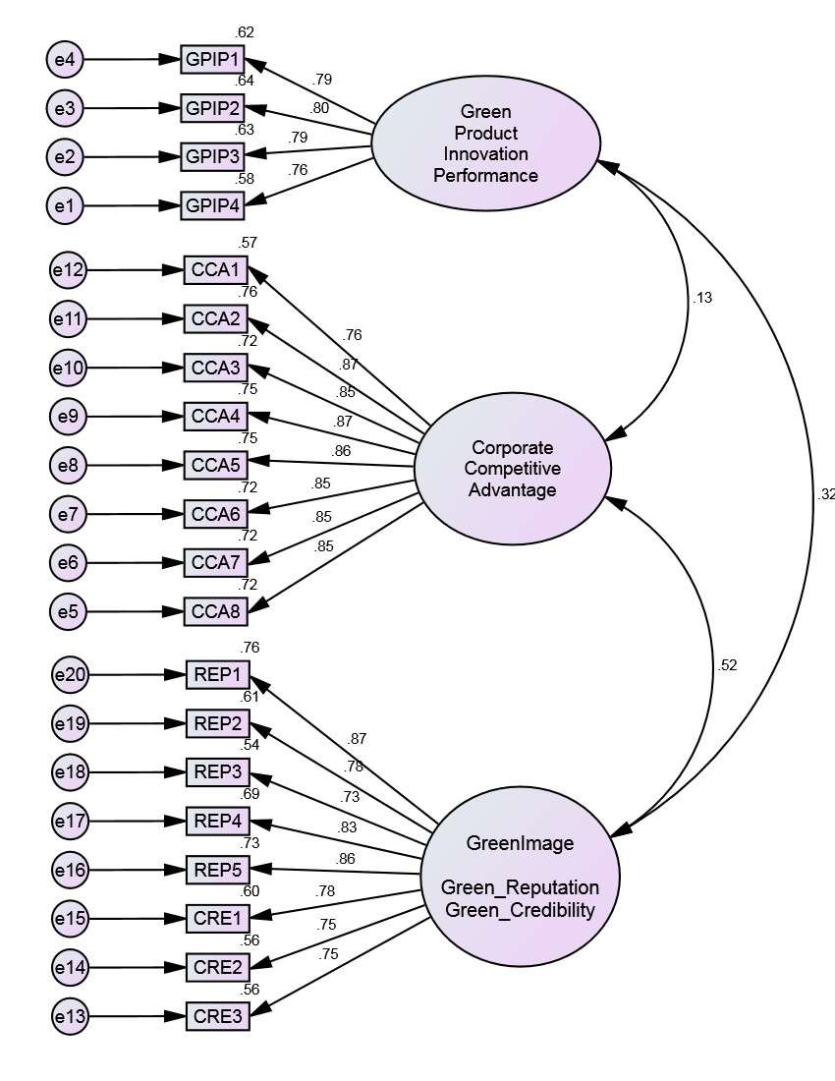

**Figure 2: Measurement Model**

**Table 1: Reliability and Convergent Validity**

|  |  |  |  |  |  |
| --- | --- | --- | --- | --- | --- |
|  |  | Reliability | | Convergent Validity | |
| Constructs | Items | Cronbach’s Alpha (α) | Composite Reliability | Standardized Loadings | Average Variance Extracted |
| Green purchase intentions performance | GPIP1  GPIP2  GPIP3  GPIP4 | 0.863 | 0.865 | 0.785  0.800  0.791  0.762 | 0.616 |
| Corporate Competitive Advantage | CCA1  CCA2  CCA3  CCA4  CCA6  CCA7  CCA8 | 0.952 | 0.952 | 0.756  0.874  0.846  0.869  0.865  0.846  0.846  0.850 | 0.714 |

Discriminant validity was tried by contrasting the shared variances amongst components and singular element AVE (Fornell & Larcker, 1981). Table 3 demonstrates that every shared variances between elements in the model were lower than the square root of the individual component AVE, affirming acceptable discriminant legitimacy and that that the constructs were both theoretically and experimentally different from each other.

**Table 2: Correlations of Latent Variables and Square Root of AVE**

|  |  |  |  |
| --- | --- | --- | --- |
| Variables | Green product innovation performance | Corporate competitive advantage | Green Image   * Green Reputation * Green Credibility |
| Green product innovation performance | 0.785 |  |  |
| Corporate competitive advantage | 0.133 | 0.845 |  |
| Green Image   * Green Reputation * Green Credibility | 0.321 | 0.516 | 0.794 |

*Note: Correlations of latent constructs are off-diagonal and square root of AVE is on diagonal.*

The ranges of measurement model fit index were acceptable. CFI=0.952, NFI=0.919, AGFI=0.836, TLI=0.945, IFI=0.952 and RMSEA= 0.066.

* 1. **Structural Model**

The fitness of structural model and hypotheses testing was done by using AMOS 23.The confidence level at which this study is significant is 95%.The ranges of structural model fit index were acceptable. CFI=0.936, NFI=0.903, AGFI=0.817, TLI=0.927, IFI=0.936 and RMSEA= 0.076. Standardized path coefficient for each significant causal impact is illustrated in figure 03.

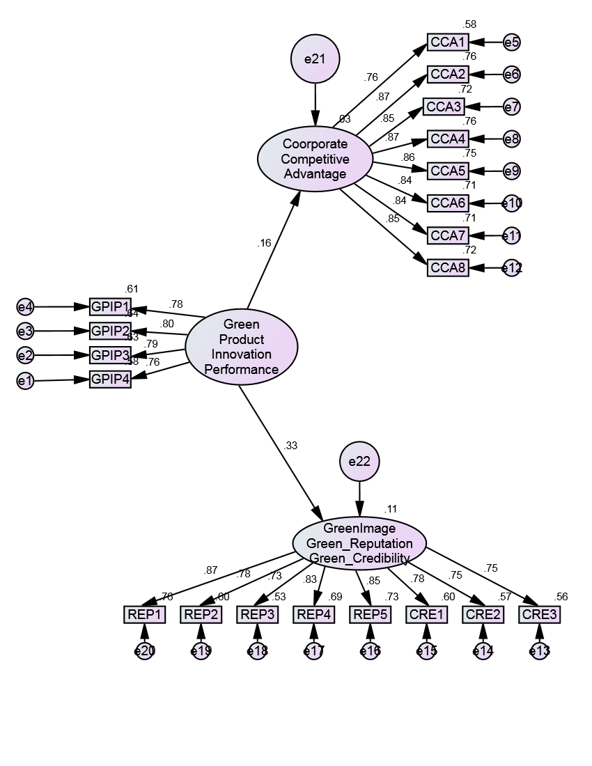

**Figure 3: Structural Model**

Results indicated that both two hypotheses were supported. Green product innovation performance was found to has significant and positive impact on corporate competitive advantage (β=0.159, *p*=0.013) and green image (β=0.332, *p*=***).

**Table 4: Hypotheses Results**

|  |  |  |  |  |
| --- | --- | --- | --- | --- |
| Hypothesis | Hypothesized Path | Standardized Path Coefficients | p-value | Results |
| H1 | Green product innovation performance ➔ Corporate competitive advantage | 0.159 | 0.013 | Supported |
| H2 | Green product innovation performance ➔ Green Image (Green Reputation, Green Credibility) | 0.332 | *** | Supported |

*Note: p< 0.05; *** p<0.001*

# DISCUSSION AND CONCLUSION

* 1. **Discussion**

The aim of this research study was to determine the impact of green product innovation performance on corporate competitive advantage and green image (green reputation, green credibility) in automobile sector of Pakistan. The exogenous variable of the study was green product innovation performance while corporate competitive advantage and green image (green reputation, green credibility) were endogenous variables of the study. Table 04 indicated standardized path coefficient and p-value of the relationship between green product innovation performance and corporate competitive advantage and found significantly positive relationship. Therefore, H1 was supported. The value of standardized path coefficient is 0.159 and p value is 0.013. The outcome shows that the more the interest in the green product innovation was, the more grounded the corporate competitive advantage was. The finding of the study was consistent with the work of Chen, Lai, & Wen, (2006), who found the relationship among green product innovation performance and corporate competitive advantage in covering the semiconductor industry, the information hardware industry, the optoelectronic industry, the communication industry, the consumer electronics industry and the electronic component industry in Taiwan and found significantly positive relationship.

* 1. **Conclusion and recommendations**

Convincingly, different striking concentrations are highlighted in this study and essential suggestions are given for managers. One of the important contributions of this review in existing literature is that is scrutinized the impact of green product innovation performance on corporate competitive advantage in automobile sector and found positive relationship. Managers ought to pick the materials of the item that deliver minimal measure of pollution, consume minimal measure of vitality and assets and least measure of materials to include the item to conduct the item improvement or plan. By focusing on all these points, managers can give careful consideration on items and administrations of organization, R&D and innovation, administrative capacity, corporate picture of the organization, profitability and growth of the company.

* 1. **Limitations and future directions for research**

This research study had few limitations. First of all, this research study focused on automobile sector. In future researchers can choose different sectors such as electronic industry. This research study had led in Lahore, Pakistan. In future, researchers can choose different cities of Pakistan. As the nature of this study is cross sectional, therefore the researchers in future can acquire time series data. This research study focused only on green product innovation performance. In future, researchers can select green process innovation performance to find out its impact on competitive advantage and green image. Researchers can also find out the impact of green product innovation performance on other variables such as market share.

REFERENCES

Audretsch, D. (1995). *Innovation and Industry Evolution.* Cambridge: MIT Press.

Audretsch, D., & Keilbach, M. (2004). Entrepreneurship and Regional Growth:An Evolutionary Interpretation.”. *Journal of Evolutionary Economics, Vol.14, No.5*, 605-616.

Baltagi, B. (2001). *Econometric Analysis of Panel Data, 2nd ed.* Chichester: John Wiley and Sons.

Baumol, W. (1996). Entrepreneurship: Productive, unproductive, and destructive. *Journal of Business Venturing, Vol.11, Issue 1*, 3-22.

Bednarzik, R. (2000). The role of entrepreneurship in US and European job growth. *Monthly labor review / U.S. Department of Labor, Bureau of Labor Statistics 123(7)*, 3-16.

Blanchower, G. (2000). Self-employment in OECD countries. *Labor Economics 7*, 471-505.

Chemin, M. (2009). The impact of the judiciary on entrepreneurship: Evaluation of Pakistan's "Access to Justice Programme. *Journal of Public Economics, Elsevier, vol. 93(1-2)*, 114-125.

De Clercq, D., Wade M., D., & Dakhli, M. (2010). The moderating effect of institutional context on the relationship between associational activity and new business activity in emerging economies. *International Business Review, Elsevier, vol. 19(1)*, 85-101.

Ericson, R., & Pakes, A. (1995). Markov-Perfect Industry Dynamics: A Framework for Empirical Work. *Review of Economic Studies, Vol. 62*, 53-82.

Feki, C., & Mnif, S. (2016). Entrepreneurship, Technological Innovation, and Economic Growth: Empirical Analysis of Panel Data," Journal of the Knowledge Economy, Springer. *;Portland International Center for Management of Engineering and Technology (PICMET), Vol 7*, 984-999.

Hopenhayn, H. A. (1992). Entry, Exit, and Firm Dynamics in Long Run Equilibrium. *Econometrica, Econometric Society, vol. 60(5)*, 1127-1150.

Hubbard, R. G. (2008). Nondestructive Creation: Entrepreneurship and Management Research in the Study of Growth . *Journal of Policy Modeling, Vol.30, No.4*, 595-602.

Jovanovic, B. (1982). Selection and the Evolution of Industry. *Econometrica, vol. 50, issue 3*, 649-670.

Kirzner, I. (1973). *Competition and Entrepreneurship.* Chicago: University of Chicago Press.

Klepper, S. (1996). Entry, Exit, Growth, and Innovation over the Product Life Cycle. *American Economic Review, Vol. 86, No.3*, 562-583.

Koo, J., & Kim, T. (2009). When R&D matters for regional growth: A tripod approach. *Papers in Regional Science, Volume 88 Number 4*.

Levine, R. a. (1992). A sensitivity analysis of cross-country growth regressions. *American Economic Review, 82*, 942-963.

Levine, R., & Zervos, S. (1993). What We Have Learned about Policy and Growth from Cross-Country Regressions? *American Economic Review, vol. 83, issue 2*, 426-430.

Pitlik, H. (2002). The Path of Liberalization and Economic Growth. *Kyklos, Vol.29, No.1*, 57-79.

Sachs, J. D., & McArthur, J. W. (2002). Technological advancement and long-term economic growth in Asia. In *Technology and the New Economy* (pp. 157-185). MIT Press Cambridge.

Schumpeter, J. (1934). *The Theory of Economic Development: An Inquiry into Profits, Capital, Credit, Interest, and the Business Cycle.* Cambridge: Harvard University Press.

Solow, R. (1957). Technical Change and the Aggregate Production Function. *Review of Economic and Statistics,39*, 312-320.

Troilo, M. (2011). Legal institutions and high-growth aspiration entrepreneurship. *Economic Systems, Elsevier, vol. 35(2)*, 158-175.

Versloot, P., & van Praag, M. (2007). What is the Value of Entrepreneurship. *A Review of Recent Research.”Small Business Economics, Vol. 29, No.4*, 351-382.

Wennekers, S., van Stel, A., Thurik, R., & and Reynolds, P. (2005). Nascent Entrepreneurship and the Level of Economic Development. *Small Business Economics, 24*, 293-309.

Wong, P., Ho, Y., & Autio, E. (2005). Entrepreneurship, innovation and economic growth: evidence from GEM data. *Small Business Economics, Vol.24*, 335-350.